How to Deal with Addiction First Hand?

Dealing with addiction is truly challenging and often times, exasperating. More often than not, a person addicted to a certain substance, product, or act, doesn’t even recognize that there is indeed a problem. If you are one of those lucky enough to recognize that you have an addiction problem, and you are determined to take the necessary steps to resolve it, then here are some tips on how to deal with your addiction first hand.

Accept that you have an addiction
In dealing with addiction, the first step is to recognize and accept that there is indeed a problem. Identify what it is that you are addicted to, whether it is a particular substance, alcohol, smoking, gambling, shopping, or excessively using your gadgets. There are basically two methods that can help you deal with your addiction once you identify what it is you are addicted to. You can either try to quit gradually or immediately, but both methods are equally challenging.

Once you recognize that you have a problem, make a list of reasons on why your addiction is not good for you. Take into consideration the areas in your life that is affected such as your health, your relationships, or your finances, among others. Keep this list somewhere that you can always see to remind you on why you want to quit in the first place. You can post this on your bedside table or keep it in your wallet. This will help you resist the temptation of reaching for another cigarette for instance, or playing another game in the casino.

Take gradual steps
Taking gradual steps to cease your addiction may work in some instances and may fail to be effective in others. It usually depends on what you are addicted to. For instance, if you are a heavy smoker, and eventually decides to quit, taking gradual steps such as reducing the number of sticks you light up per day may be effective, until such time that you are down to the very least number of sticks. You can also do this if you are addicted to gadgets by trying to set a limit on the number of hours you use your devices. Reduce the number of hours gradually until you notice that you are already spending the number of hours than an average person does. Conversely, this might be ineffective for other forms of addiction, such as substance abuse or alcohol addiction wherein the state of mind is altered.

Seek for help
True enough that you have power over your mind and body, but oftentimes, when a person is in the euphoria brought about by the element that is making him addicted, his or her decisions are often clouded. It is in these instances wherein you need to seek for help. You can start by opening up to your closest family and friends. If you are a heavy smoker, a family member can help you by ensuring that you reach your goal in gradually reducing your cigarette consumption. In the same manner, a close friend can help you by taking away your gadget once you surpass the time you set for yourself.

While it can be difficult, you may need to also seek the help of the professionals, depending on your addiction and its level. Changing Tides and other facilities has a goal of helping people overcome their addiction especially from substance abuse. More often than not, these facilities offer a real-world environment with several family programs, as well as clinical services. You might be lucky if you find yourself in a facility with an astounding location to help you recover, such as within a beach location. The programs normally vary and can range anywhere from a residential rehab or intensive outpatient. Nevertheless, the experts will assess which program is the most suitable for you to eventually help you to break free from your addiction.

The “Cold Turkey” method
Turning back from something you are addicted to instantly, is extremely difficult, but this proves to be more effective. Depending on your level of addiction, you can overcome this phase by keeping yourself busy. More often than not, this method has been successful for people who chose to seek the proper help.
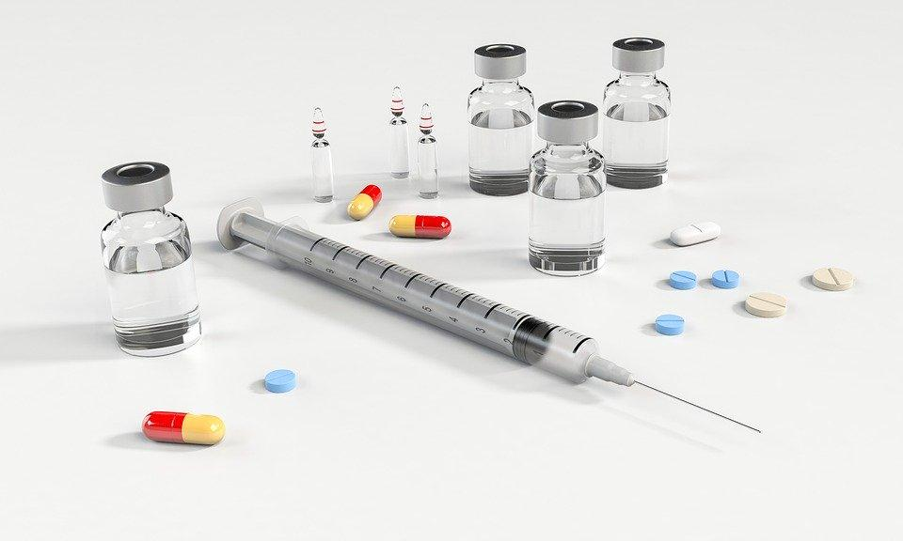

Dealing with addiction is an entire process that truly cannot be resolved overnight. While it is true that the support of your family and friends will definitely help you get through this difficult phase in your life, keep in mind that the power to completely get over this phase and move on is in your hands. Thus, recognizing that you have a problem with addiction is already a big leap towards your recovery.

